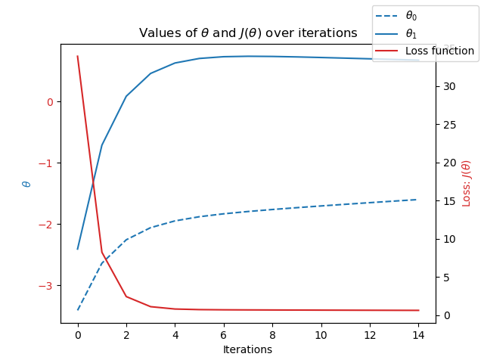
Optimization in Relating to Problem-Solving
Station: Madrid
Year: 1973
Iterations = 15
Theta0 = -5
Theta 1 = -6
Steps = 0.1

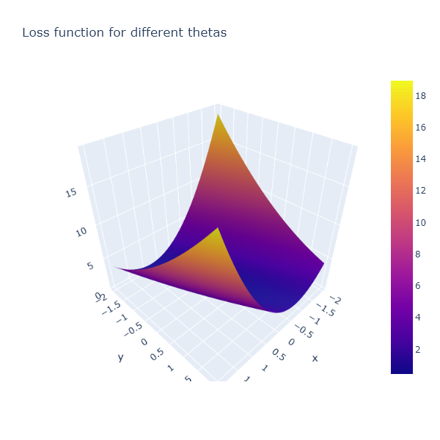
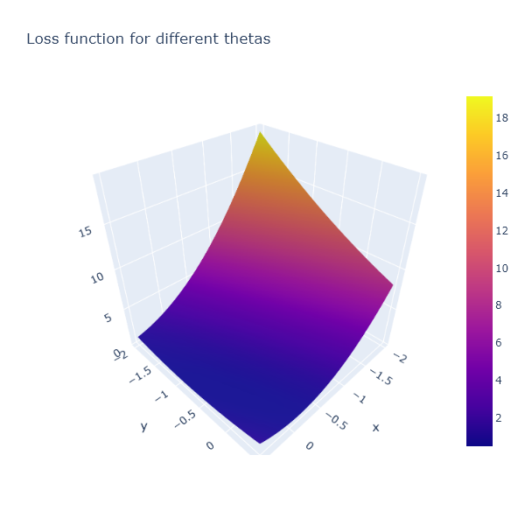
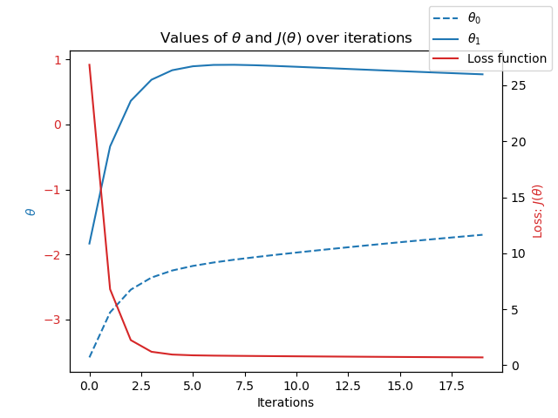
Station: Gdansk
Year: 1997
Iterations = 20
Theta0 = -5
Theta 1 = -5
Steps = 0.1

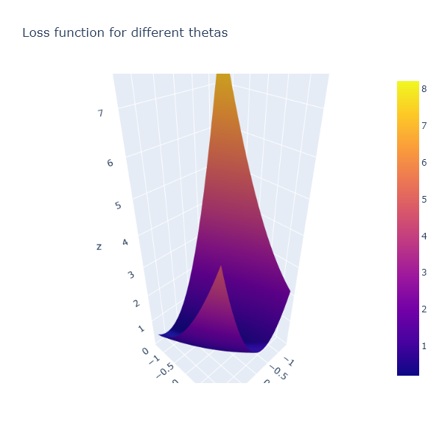
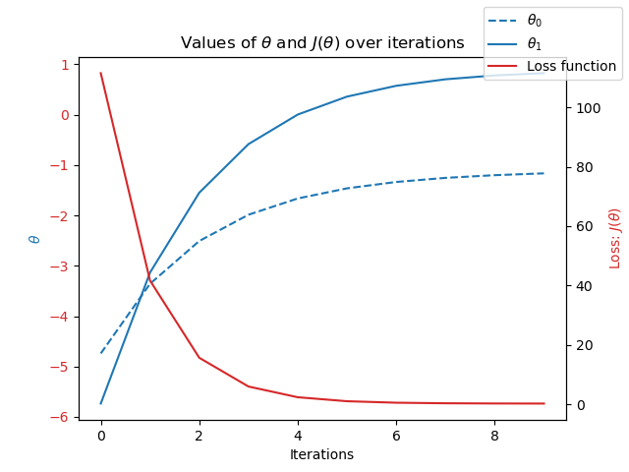
Station: Oslo
Year: 2022
Iterations = 10
Theta0 = -7
Theta 1 = -10
Steps = 0.1

My observations between these three weather stations and their distribution varies. Studying Madrid and Gdansk there is a large difference between theta0 and theta1 with both loss functions far from crossing both theta’s. However, Oslo in year 2022 shows a much closer representation of theta0 and theta1. The Loss function also crosses both thetas almost perfectly.

